**WorkforceONE Mobile App – Quick Start Guide**

From the App Store or Google Marketplace, search for ***HCMToGo*** and download the app. Examples from the iPhone App Store (left) and Google Play (right) are shown below.

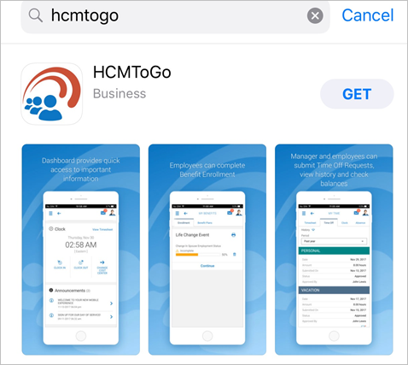 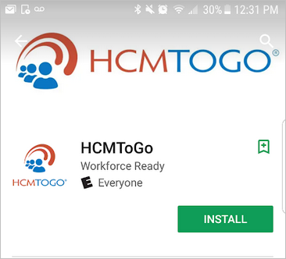

The first time you open the app, it will ask for your company shortname. Ours is **PPCxxxx**(not case sensitive).

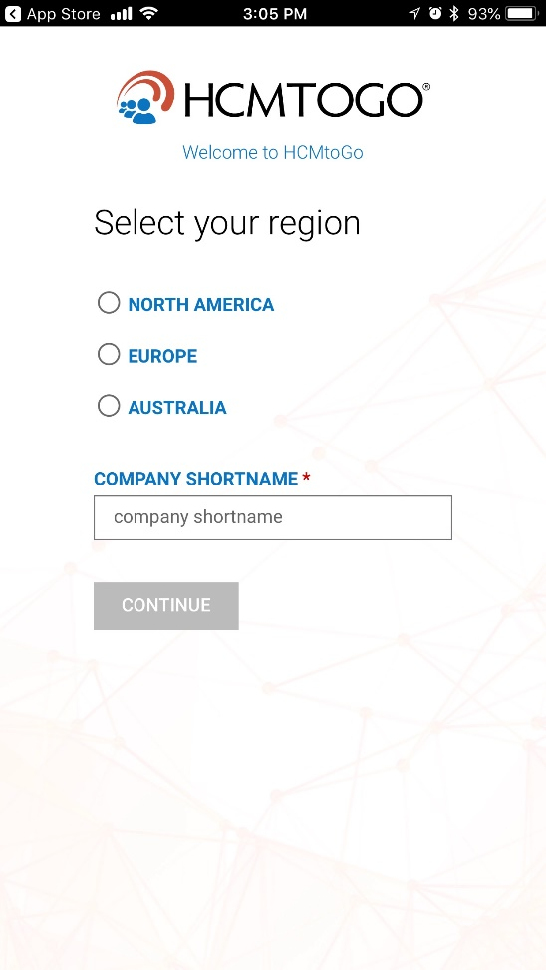

You will then be prompted to receive a virtual authentication code for your first log in, just like the desktop version of WorkforceONE (“WFO”). Be sure to check off the box so that the system remembers your device and does not prompt you for an authentication code the next time that you log on.

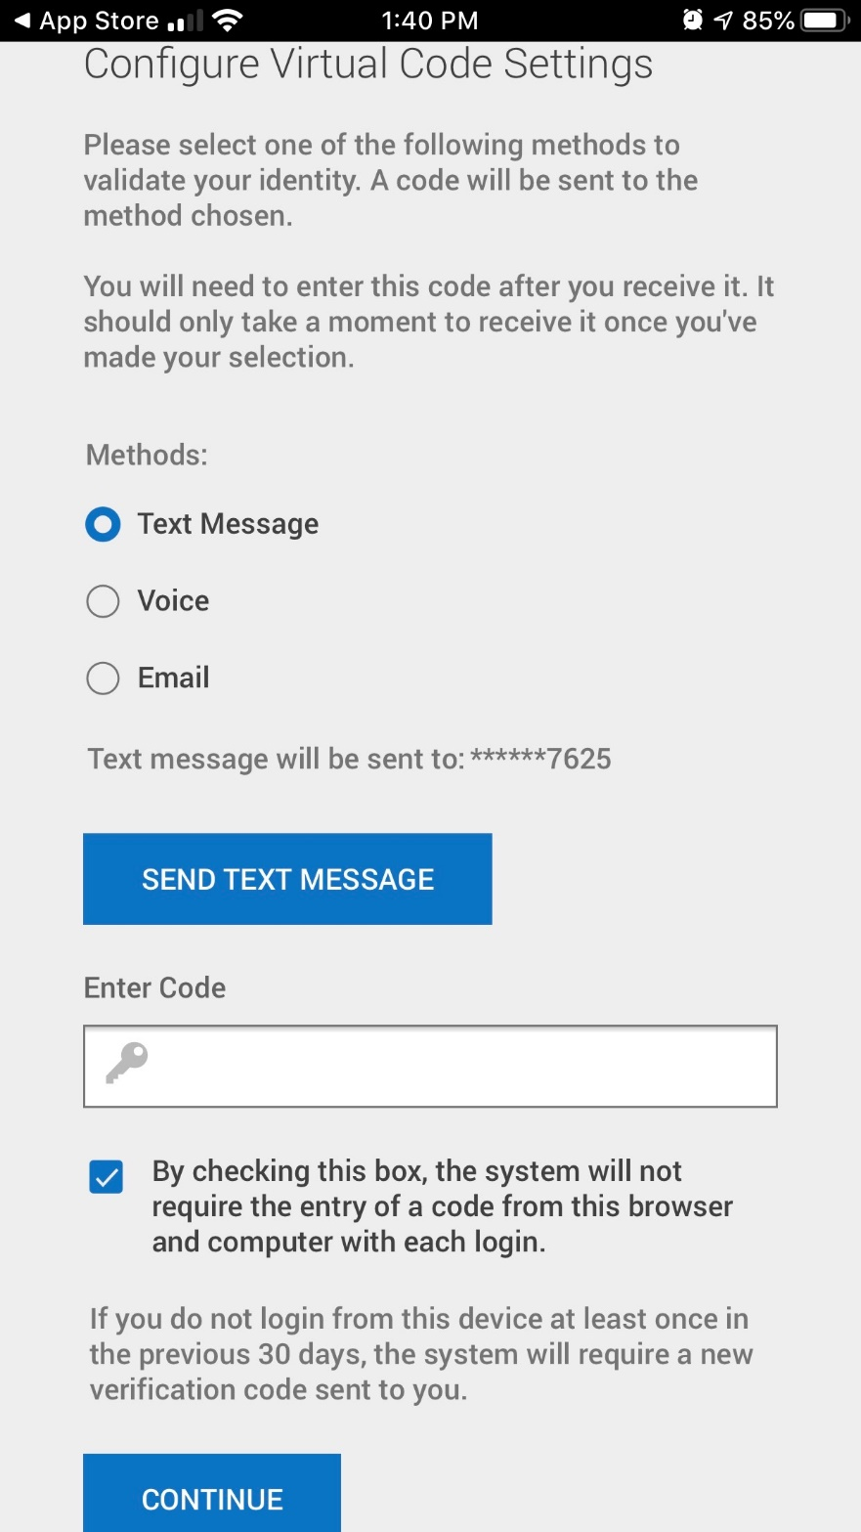

Your login credentials are the same Username and Password that you presently use to access WFO from your desktop. Enter those credentials and then click on the LOGIN button.

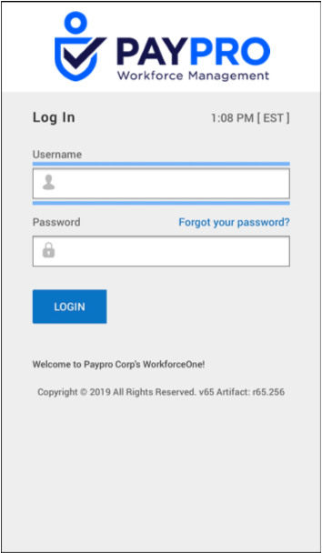

Upon logging in, you will be presented with a dashboard of widgets configured for easy access to convenient information. You may see different widgets based on your individual setup; below are examples of the most commonly-used ones.

* **Clock:** here you can see your last punch and follow the *Clock* hyperlink to your current timesheet. If your security allows access to punch in/out via mobile, you can do so here.

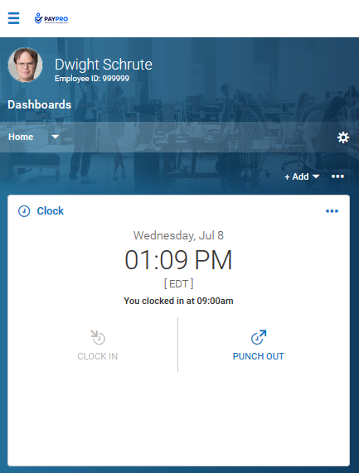

* **Announcements:** we may place special announcements on your dashboard. You can view these by tapping on either the Info icon or the arrow. To close the announcement, tap the X or tap Close.

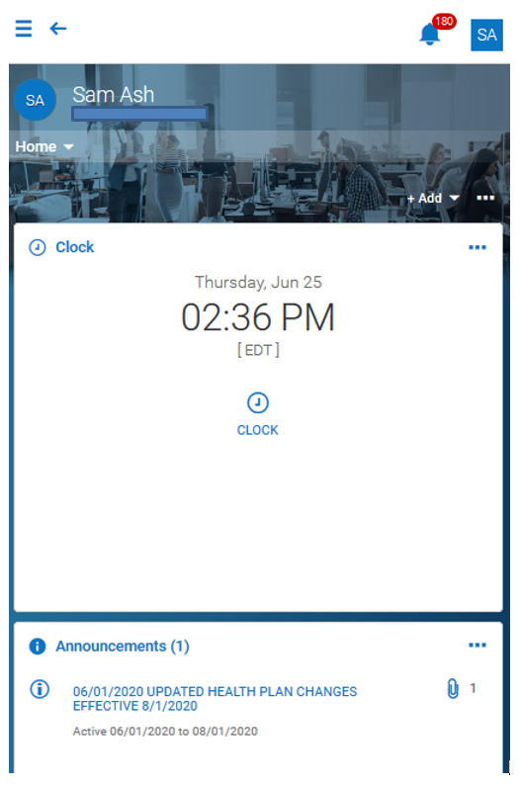

* **Time Statistics:** this will display a snapshot of the current pay period and update automatically each time you punch out.

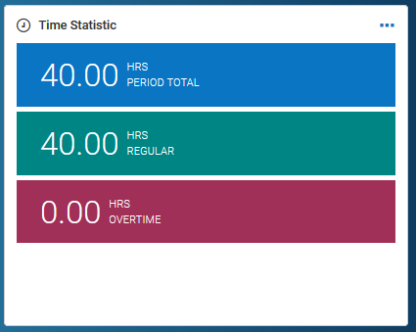

* **Timesheet Chart:** this will display, in real time, your total hours for each day of the current week. The current day will display as highlighted. The data will update automatically as time is added to your timesheet.

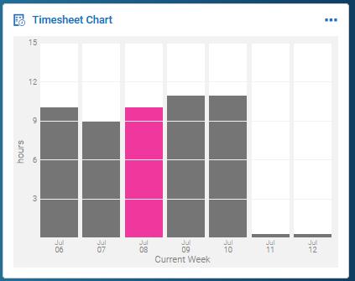

* **My Pay:** you can see a countdown until your next check. By tapping the *My Pay* hyperlink, you can view your pay history, and you can view direct deposits and tax forms.
  + You can tap the *Download Pay Statement* link and the pay statement will display in PDF on a separate page. From there, you can download and save the PDF to your device. To return to your session without having to logout, tap the name of your App at the very top-left of your device.

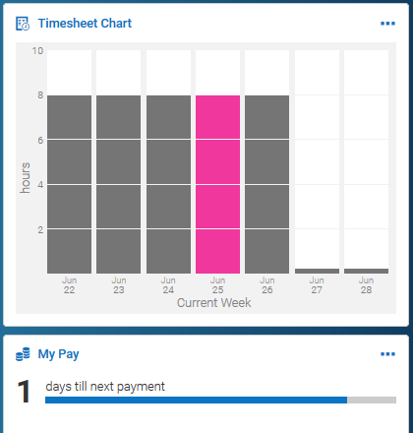

* **My Benefits:** you can view your current benefit plans, and when available, you can enroll in benefits during an open enrollment period, or to process a life change event.
  + Tap the *Benefits* hyperlink to be taken to the page containing your existing benefits and enrollments. Tap the Back arrow at the top of your session to return to the home page, one page at a time; or, you can tap the hamburger icon and tap the Home icon.

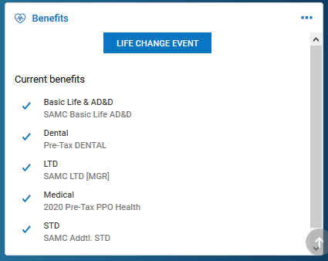

* **Accrual Balances:** this will show you any time offs you may accrue. You can toggle between viewing in hours and days. From here you can start a time off request, or click the *Accrual Balances* hyperlink to see more details on how your current balance has been calculated.

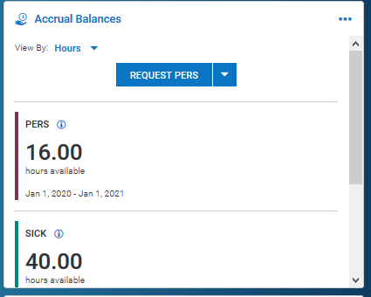

The “hamburger” icon at the top-left of your session can be clicked to open the menu containing all pages that have been configured for your experience. There will be settings such as your Home icon, your Sign Out link under your initials or photo, a quick search field, and other menu options. This menu can be accessed at any time, within any menu. You can also swipe to the right to activate the main menu, though this may vary by device. Once active, it can be closed by tapping the X in the rolled-out menu.

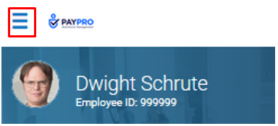

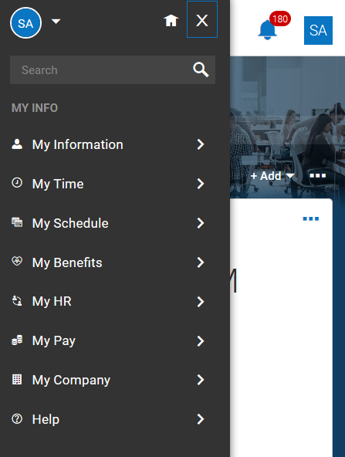

**Some Employee Navigation Tips within the MY INFO Menu:**

* **View Balances and Request Time Off:** My Time > Time Off > Balances *or* Request
* **View Schedule:** My Schedule > Schedule
* **Make a Timesheet Change Request:** My Time > Timesheet > Change Request
* **View Timesheet:** My Time > Timesheet > Timesheet

A manager menu has two options; one for your own information, named *My Info*, and another option for the employees who report to you, named *Team*.

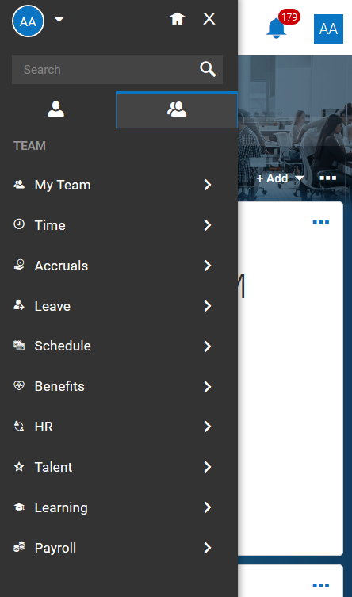

**Some Manager Navigation Tips within the TEAM Menu:**

* **View Team and Current In/Out Times:** My Team > Team Members
* **Approve Submitted Timesheets:** My Team > Time > Timesheets
* Select “Current View” then “View By” to change to Pending Approval
* **View, Edit, and/or Approve Timesheets:** My Team > Time > Timesheets > Timesheets
* **Schedules:** Schedule > Team Schedule View
* **Time Off Calendar:** My Team > Time > Time Off > Time Off Calendar
* **Unlock Employee:** HR > Employee Maintenance > Password Unlock

Note that anywhere you come across ellipses on a screen, it indicates there are more choices available.

